**TASK 3.3**

**Step 1:**

**What film genres already exist in the category table?**

Category Id Genre

1 "Action"

2 "Animation"

3 "Children"

4 "Classics"

5 "Comedy"

6 "Documentary"

7 "Drama"

8 "Family"

9 "Foreign"

10 "Games"

11 "Horror"

12 "Music"

13 "New"

14 "Sci-Fi"

15 "Sports"

16 "Travel"

**Step 2**

**Write an INSERT statement to add the following genres to the category table: Thriller, Crime, Mystery, Romance, and War:**

2.a INSERT INTO category(name)

VALUES ('Thriller'),('Crime'),('Mystery'),('Romance'),('War');

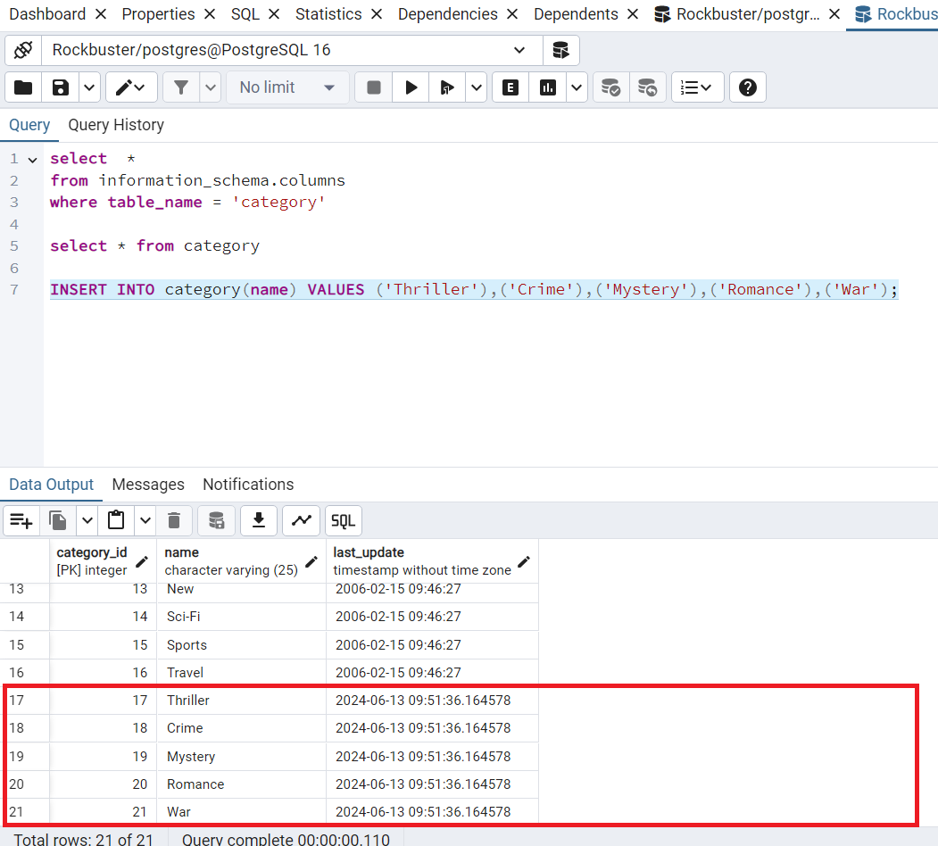

2.b The constraints have been applied to the single columns in the table.

– category_id has two constraints: NOT NULL and DEFAULT. By default, this column can have NULL values. However, there constraints ensure that the column won't contain empty values and if no value is specified, a DEFAULT value is provided.

- name cannot store empty values with NOT NULL. COLLATE organizes the order of the text in the column.

- last_update, similar to category_id, uses the DEFAULT constraint to assign a default value when no value is provided. The NOT NULL constraint ensures that this column cannot contain empty values.

- category_pkey CONSTRAINT is used to name the primary key. It's similar to assigning an alias to the primary key constraint. The PRIMARY KEY is essentially a combination of NOT NULL and UNIQUE constraints, and it ensures that each value in the primary key column is unique and not null.

**Step 3:**

**3a Once you have the film_ID and category_ID, write an UPDATE command to change the category in the film_category table (not the category table). Copy-paste this command into your answers document.**

3a. select film_id

from film

where title ='African Egg';

Output :

film_id :5

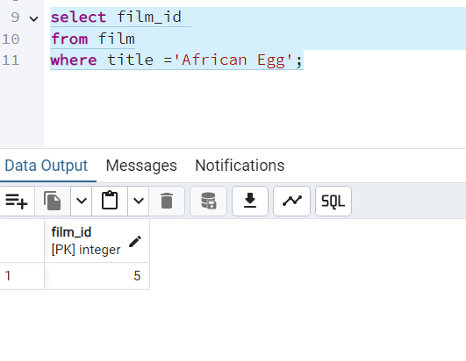

**3.b**

**Once you have the film_ID and category_ID, write an UPDATE command to change the category in the film_category table (not the category table). Copy-paste this command into your answers document.**

1. Find the film_id for African Egg

select film_id

from film

where title ='African Egg';

output :

film_id : 5

2.Find the corresponding category_id for film_id :5

select category_id

from film_category

where film_id =5;

output :

category_id : 8

3.Find the genre which corresponds to category_id : 8

select name from category

where category_id =8;

output :

genre : family

5. Find the category_id to genre Thriller

select category_id from category

where name = 'Thriller'

output

category_id : 17

6. UPDATE command to change the category in the film_category table

update film_category

set category_id = 17

where category_id =8

**Step 4:**

**Since there aren’t many movies in the mystery category, you and your manager decide to remove it from the category table. Write a DELETE command to do so and copy-paste it into your answers document.**

delete from category

where name = 'Mystery';

output DELETE 1

**Step 5:**

**What would it be like to complete steps 1 to 4 with Excel instead of SQL. Are there any pros and cons to using SQL? Write a paragraph explaining your answer**.

|  |  |
| --- | --- |
| **Pro’s of using SQL** | **Cons of using SQL** |
| SQL is more efficient and faster | Dependency on Documentation: Requires an ERD (Entity-Relationship Diagram) or Data Dictionary to understand the structure and relationships within the database. |
| The process is less manual, which reduces the risk of error | Complexity:  Requires knowledge of SQL syntax and database design principles. |
| Performance: Optimized for complex queries, indexing, and fast data retrieval. | Setup and Maintenance: Requires setup, configuration, and ongoing maintenance of database servers. |
| Automation: Automates repetitive tasks, reducing the time spent on manual data entry |  |

**BONUS TASK**

CREATE TBL 3EMPLOYEES

{

employee_id VARINT(30) NOT EMPTY

name VARCHAR(50),

contact_number VARCHAR(30),

designation_id INT,

last_update TIMESTAMP NOT NULL DEF now()

CONSTRAIN employee_pkey PRIMARY KEY (employee_id)

}

**Solution:**

**CREATE TABLE EMPLOYEES**

**(**

**employee_id VARCHAR(30) NOT NULL,**

**name VARCHAR(50),**

**contact_number VARCHAR(30),**

**designation_id INT,**

**last_update TIMESTAMP NOT NULL DEFAULT now(),**

**CONSTRAINT employee_pkey PRIMARY KEY (employee_id)**

**);**

